CONTRACT UH2015/09

Supplement of Delivery

# Introduction

This document lists the supplements of delivery to the contract UH2015/09. In specific, this document lists the updates and repairs to the HNOSS Horizontal Cryostat System that Uppsala University acquired from Cryo Diffusion S.A.S., Lery, France, under contract UH2012/76 "Horizontal Test Cryostat" from September 2013.

# Repair of the Interconnection Valve Box (ICB)

Contract UH2012/76 included delivery and installation of one (1) Interconnection Valve Box (ICB). The ICB connects the helium liquefaction plant to the Vertical Valve Box of the HNOSS horizontal cryostat. The ICB was delivered to Uppsala University in August 2014. During operation within the warranty period October 2014 to October 2015 the ICB developed leaks between the liquid nitrogen circuit and the insulation vacuum and between the liquid helium circuit and the insulation vacuum. The leaks shall be repaired.

# Delivery of the instrumentation box

Contract UH2012/76 included delivery of the instrumentation box used for the testing of the temperature sensors prior to connection to the control cabinet. This box shall be provided.

# Update of the Horizontal Cryostat Control System

Contract UH2012/76 included delivery and installation of one (1) control system. The control system has several functionality issues listed below that are to be solved by updating its software program.

## Bugs/glitches

* 1. Sometimes the GUI value is different from the value shown in the controller. As an example, PT102 in the GUI shows 20.08 mbar but in the controller it shows 25 mbar. Looks like when the trend line of PT102 is constant the reading might not be correct.
  2. CV551
     1. This valve did not closed when the pressure was changed in sequence 9 (valve should have closed), and after a short time it did close but it was not shown on the GUI after a short while later (knew it was closed because the flow was much smaller).
  3. CV552: During the last run this valve is commanded close or opened in manual mode but the command is not followed.
  4. When directing 4K gas to Kaeser
     1. Sometimes the valves do not follow the commands given by the switching and stay in the same position. Takes several tries before it finally works.

## General Controller problems

* 1. MKS controllers:
     1. PT550 never switches to PT100. When should it switch?
     2. PT100 is used in sequence 5, but since it never switches from PT550 there will be no warning if pressure rises, shouldn’t it be changed to PT550 instead (or MKS2)?
     3. PT551 does not switch over to PT552. When should it theoretically switch? PT551 (range 1333 mbar) has been recording from 0.3 mbar (when purging the line) up to 1400 mbar.
     4. Clear alarms: why do they appear?

## Sequences

* 1. Sequence 8
     1. How is the regulation of the 2K tank done? Sometimes LT101 does not regulate although it should because the option is selected in the popup window.
     2. How is the regulation of the table done? Sometimes this valve doesn’t open although the max temperature is reached.
     3. Which valve opening goes first when both the table and the 2K tank are set to regulate? And when they are not set to regulate?
  2. Sequence 9
     1. While the 2K pumps were pumping down to 20 mbar (took a very long time, more than usual), almost at the end CV551 closed and the pressure started to go up. Glitch in MKS3?? Or is there a timer in sequence 9 (PLC program)?
     2. How is the regulation of the 2K tank done? LT101 does not regulate although it should because the option is selected in the popup window.
     3. How is the regulation of the table done? Sometimes this valve doesn’t open although the max temperature is reached.
     4. Which valve opening goes first when both the table and the 2K tank are set to regulate? And when they are not set to regulate?
  3. Sequence 12B
     1. EH104AC did not switch off although the setpoint of 170 K was reached. How is this sequence regulating the temperature? Will it keep on heating until ALL sensors are above the setpoint?
     2. Same for EH102AB. How is this sequence regulating the temperature? Will it keep on heating until ALL sensors are above the setpoint?

## To implement

* 1. Purging system
     1. Clear “Purging system” alarm. Where does it come from? From FV011 or from where/what?
     2. FV011: the valve is commanded close even though it should be normally open. Have problems with this valve since it has to be manually opened/closed when running sequences 1 to 3.
  2. CV550, CV551 and CV552 (see Figure 1)
     1. When cable is disconnected the system does not show any alarm or gives an indication in red.
     2. When this happens, in the interface this valve shows open and then closes (5s) and this is repeated every 30s, but clearly the valve is not opened since the cable is disconnected.
  3. FV558 (see Figure 1): when cable is disconnected the system does not show any alarm or gives an indication in red, not even when the status is changed (forced open, close or in remote).
  4. Sequence 1: In the grafcet it states CV550 and CV552 to be opened during pumping: wrong. Change this valve to be closed (there is a FT right after). Are all the grafcets according to the system as it is after all the changes?
  5. Sequence 12A: EV400 does not automatically open, have to do it manually. Maybe is not needed?

* 1. Sequence 12B (HNOSS warmup): should not be necessary to switch off sequence 3A (ICB warmup).
  2. Sequence 13 (HNOSS isolated)
     1. Re-check this sequence completely, since it doesn’t isolate the system. The valves remain as they were prior to selecting this sequence.
     2. CV551 should be kept closed.
     3. Change text from PT100 and PT101 to MKS2 and MKS3.
     4. PT300, PT301 and PT302 should not affect CV550, CV551 and CV552.
     5. When stopped CV550 and CV552 should close (CV551 should already be closed from the beginning).

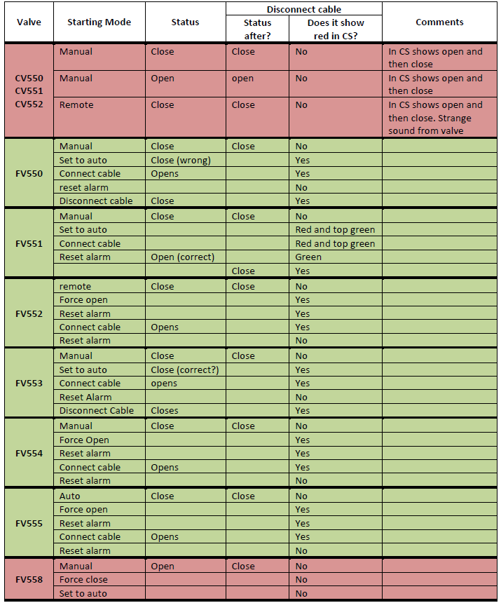

Figure 1. Checked behaviour of several valves when connecting/disconnecting cables.