**Summary of the teleconference FREIA-ACS, 18/04/2017**

**Participants:** Roger RUBER (UU), Rocio SANTIAGO (UU), Konrad GAJEWSKI (UU), Lars HERMANSSON (UU), Johan ERIKSSON (UU), Jean-Pierre THERMEAU (ACS), Philippe BUJARD (ACS), Tomas JUNQUERA (ACS), Florian DIEUDEGARD (ACS)

During the meeting, ACS did an overall review with FREIA of the Gersemi project.

The main points were:

1. The mechanical study of the magnet insert

ACS summed up the meeting with Karl-Heinz Röhlich (sales manager from Pro-Beam) and Cryo Diffusion at Lery.

After a short lecture of the electron beam welding technology, a review of the heat exchanger Lambda HX683 was made to improve the design and the welding process. The expensive part of the electron beam welding is the preparation and the handling of the welded parts. Because the vessel must opened then pumped to vacuum again. The welding must be done with the minimum of manipulation. CD modified the design (initially made for brazing) and submitted it the 12th April to Pro-beam for a quotation.

A review of the manufacturing drawings for the cryostat and magnet insert was done.

1. The manufacturing flollow-up

ACS reviewed the manufacturing of the vertical cryostat.

* CD received and controlled the parts for the valve box. CD prepares the manufacturing zone and the upper flange for assembly.
* CD continues the assembly of the liquid insert
* CD performed the welding of 300mm ferrules on the lambda seat. To avoid deformation of the lambda seat, CD prepared a particular manufacturing process.
  + First, the lambda seat is roughly machined.
  + Secondly, 2 tubes of 300mm length are welded to the lambda seat using backstep welding to reduce warping and argon to avoid corrosion. The weld is filled inside then outside.
  + Thirdly, the lambda seat is sent back for a precise machining to obtain the required flatness.
  + Last step, the vessel and the neck are welded on the tubes of the 300mm. The thickness of the pipe vessel and this of the pipe of 300mm are the same, the deformations due to the welding should be reduced.
* Sominex send the vacuum vessel for cleaning. Reception and He leak test at CD is foreseen at the end of week 16.

1. The control and command

ISII-Tech and Technergie send an offer for the connection boxes. The offer details the boxes design, the associated connectors, wires and the total price (around 10k€). The boxes will gather the wires from the control components (valves, heaters) and will be fixed on their dedicated systems. They will be 4 boxes: 1 for the valve box, 1 for the cryostat and 1 for each insert (liquid and magnet inserts). A request will be done to Technergie to standardize the connectors on the insert boxes. Even if we don’t use all the wires, we will have the same connectors and cables so they will be no cable to store.

Also, a 5th connection box should be set in the pit for the instrumentation. We are waiting the study and pricing from Technergie.

ACS took into account the comments from UU about the sequences. The document was send to FREIA for validation and is expected to be send to ISII-Tech during the week so they can start the programming.

ACS will make a study for the cable paths and storage.

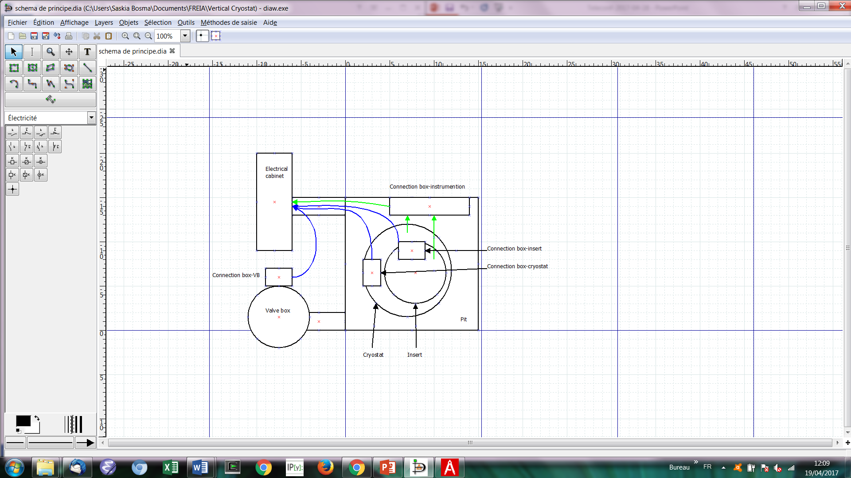

Figure 1 Schematic diagram for the cabling (blue: control wires and cables; green: instrumentation wires and cables)

1. The simulator: MicroGersemi

The simulator was modified by ACS to allow access to the helium tank and to obtain a small cryostat, MicroGersemi.

The price should be similar to that of the initial simulator.

A design review will be done with CD the 21st of April at Orsay.

A new teleconference is foreseen for May, the 10th at 9h30, via indico.

In addition to the usual points of the agenda, ACS would like that the FREIA team presents the results of the tests made on the Spoke cavities using HNOSS.