**Summary of the teleconference FREIA-ACS, 31/05/2017**

**Participants:** Rocio SANTIAGO (UU), Konrad GAJEWSKI (UU), Lars HERMANSSON (UU), Jean-Pierre THERMEAU (ACS), Philippe BUJARD (ACS), Tomas JUNQUERA (ACS), Florian DIEUDEGARD (ACS)

During the meeting, ACS did an overall review with FREIA of the Gersemi project.

FREIA presented the results of Romea Tests (run #8), 23rd Feb-29th May.

The main points were:

1. The manufacturing flollow-up

ACS reviewed the manufacturing progress of the vertical cryostat equipments.

Cryostat:

* CD received the vacuum vessel and the top lid from Sominex.
* During the first sequence of the welding, the deformation of lambda seat during the welding of the short pipe (300 mm length) was low. The flatness of Lambda seat before the machining was correct (better than 1 mm). The lambda seat was machined; CD will send us the values of the flatness measurements after machining. The second sequence of welding is started. CD is performing the welding the long tubes on the lambda seat. Welds will be controlled by X-ray. When the welding operations will be finished, CD will measure again the flatness of the lambda seat.
* The pit is prepared to receive the cryostat vacuum vessel.

Valve Box:

* The piping of the helium circuit is not started; CD sent to a subcontractor the large pipes for bending.
* The manufacturing of the thermal shield is in progress.

Magnet insert:

* Manufacturing drawing of the magnet insert is about to be completed and will be send to ACS and UU for validation after an internal check in CD.

Simulator/microGERSEMI:

* ACS is about to complete the manufacturing drawings for the simulator. A nomenclature will be sent soon to allow CD to purchase the components. The bigger flanges are already ordered and are in manufacturing by a subcontractor.

CD received the CERNOX and sent them to IPNO for calibration.

1. The control and command

ACS reported the progress made with ISII-Tech and Technergie for the cabling.

Cables from the insert connection boxes will be joined to their boxes. When the insert is removed, the cables are disconnected from the instrumentation boxes in the pit then posed on storage racks welded on the insert.

Technergie is studying the optimal size for the instrumentation box to facilitate the implementation. This box gathers cables from the insert connection box and instrumentation towers. In the worst case (magnet insert), the number of connectors is important, so is the size of the box.

Special cables from the insert will be connected to its connection box is possible (cg: AMI); others special cables (cg: coaxial on insert and cables from cryostat and VB) will directly connected to the electrical cabinet.

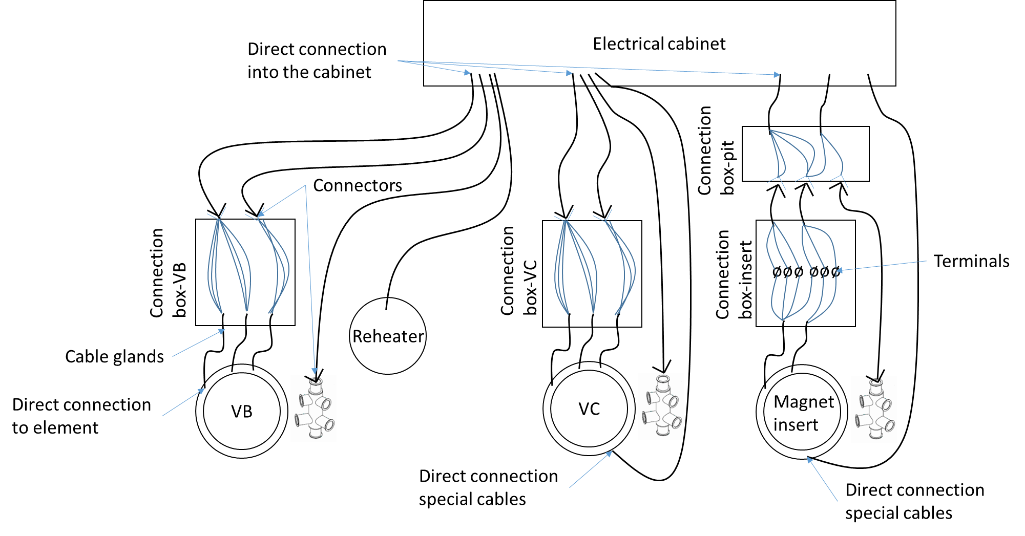

Figure 1 Cabling scheme (with magnet insert)

Technergie is updating the quotation according to ACS last comment about the cabling (Figure 1, Figure 2) from our last meeting.

ISII-Tech presented a draft software on the last meeting (29th May) at Lery and the diagrams will be send for validation to ACS. 2 sessions are foreseen with ISII-Tech to test as much sequence as possible, at the end of June and end of July.

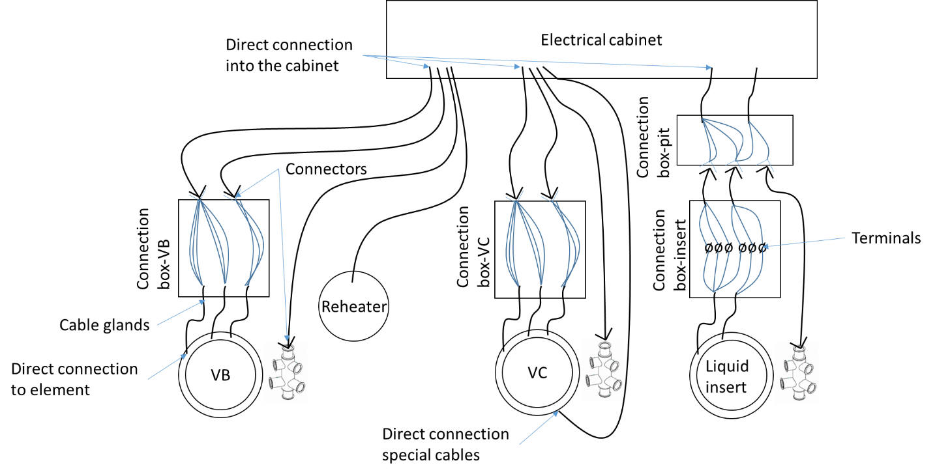

Figure 2 Cabling scheme (with liquid insert)

1. The planning

ACS informed UU about the last updates of the manufacturing planning.

* Valve box
  + W25: procurement of the semi-finished products
  + W26: manufacturing start of heat exchanger 4K
  + W27: manufacturing start of the thermal shield
* Cryostat
  + W22: cleaning, assembly, welding and control (X-ray) of the pressure vessel
  + W23: welding of cooling system and top lid on pressure vessel
  + W24: assembly of equipment
* Simulator
  + W22: reception of the nomenclature
  + W23: procurement (biggest flanges already ordered)
  + W27: start of manufacturing
* Magnet insert
  + Heat exchanger Lambda HX683: 18 weeks of manufacturing
* C&C and cabling:
  + W36: start of workshop pre cabling
    - Duration: 1 months
  + Tests in October

The next teleconference is foreseen in June to prepare the follow-up meeting at Lery (6-7 of July 2017). A doodle is ongoing to choose the date.