Summary of the teleconference FREIA-ACS, 17/10/2017

Participants: Rocio SANTIAGO (UU), Konrad GAJEWSKI (UU), Lars HERMANSSON (UU), Johan Eriksson (UU), Florian DIEUDEGARD (ACS)

A teleconference was held the 31st of October 2017, between FREIA and ACS to review the status of the GERSEMI project.
The main points were:
- Manufacturing follow-up
ACS exposed the manufacturing progress of the GERSEMI project.
- Cryostat:
The upper flange piping is done, including the insulation. The cooling pipes are under welding on the thermal shield. Instrumentation of the upper flange is ongoing (Technergie is at CD workshop this Tuesday to install the junction box).
- Magnet insert:
ACS and CD (26th October) reviewed the last manufacturing drawings of the insert, as well as the heat exchanger welding design from ProBeam. The top lid is under cutting at a subcontractor. This part is necessary to start the manufacturing of the insert (expected in week 44).
ACS received the mass flow specification (pressure drop is also required) for the current lead cooling and will define the equipment (flowmeters, heaters, thermometers).
- Bath insert:
The insert is waiting for the final cabling. The insertion of the insert inside the cryostat is foreseen in week 44.
- Valve box:
The piping is done and leak tests are ongoing before closure. Cernox were received Wednesday 25th October and their installation is ongoing.

- Transfer lines:
During the last meeting with CD, ACS clarified several points on the transfer line specifications, especially for L020 interfaces. FREIA need to confirm the interfaces positions and/or types for L011, L021, and L010.
- Simulator:
The manufacturing started in week 43 with the inner vessel. A draft translation of the manufacturing drawings is available on Drive (link send by mail).

- Command and control follow-up
- Control and command design:
The program is completed and had been checked by ACS.
- Control and command procurement:
The electrical cabinet was received by CD in week 43 and installed near the valve box in the dust-free area.
Cabling of the valve box to the cabinet is expected in week 44 and the vertical cryostat in week 45. A wooden structure will be made at CD to mimic the infrastructure of the laboratory at UU.
To complete the wiring of the junction boxes, CD requested the missing connectors, BURNDY 19 pins male, provided by UU.
- Planning
ACS showed the planning updated after the meeting between CD-ISII-TECH-ACS, 26th October. Further details can be found in the document “ACS_20171030_GERSEMI_project status”.
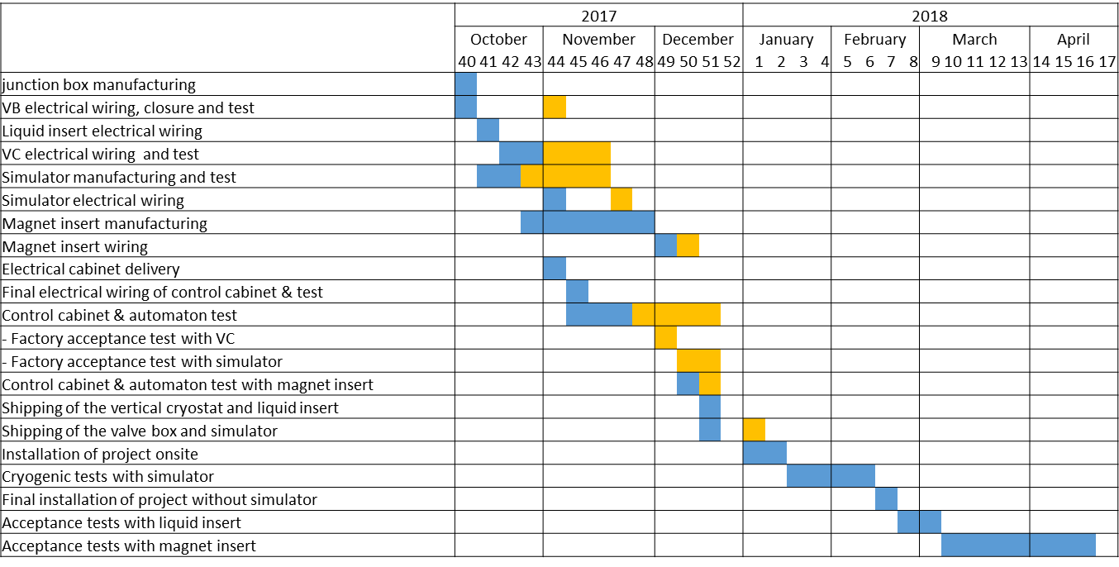
Blue: planning defined by CD at the 1st October
Orange: updates after 26th October
- Issues
Cernox calibration: agreement reached between CD and IPN. 20 calibrated cernox send with adaptors to CD to complete the instrumentation of the valve box, including the spares. The calibration machine is repaired and ordered cernox should be delivered at 15th November.
- Solved

- Commissioning tests
During the meeting with CD and ISII-TECH, the program for the commissioning tests was detailed.
Week 47-48: wiring check VC and liquid insert
Week 49: sequence tests with automaton and VC (22, 23, and 25)
Week 50-51: sequence tests with automaton and simulator (1,3,5,8,9,10,12,14,21,23)
Further details can be found in the document “ACS_20171030_GERSEMI_project status”.
- Preparation of follow-up meeting
FREIA team announced its availability for a visit at Cryo Diffusion for the end of November (week 48). It may be delay because the tests of the sequences only start in week 49. This matter will be discussed with CD to confirm the dates and prepare the visit.

