|  |  |  |  |
| --- | --- | --- | --- |
| Supporting note | | | |
| DFHX 3D preliminary model  Definition of CERN-UPSALA components supply | | | |
| **Abstract**  This document presents the limit of supply of the DFHX prototype components from Upsala University (manufacturing by RFR) and their required delivery assembly configuration. This document does not cover the requirements for the qualification, cleaning, testing and documentation.  **Disclaimer**:   * The 3D files attached in Autodesk Inventor format do not represent the final detailed DFHX model. These preliminary models aim at clarifying the suppliers of the various components. * The tooling used for assembly is not fully covered in this document. | | | |
| Traceability | | | |
| ***Prepared by:*** Y.Leclercq, F.Pillon, R.Betemps, P. Schneider | | | Date: 2020-02-14 |
| ***Verified by:*** P. Cruikshank | | | Date: |
| ***Approved by***: | | | Date: 20YY-MM-DD |
| ***Distribution***: | | | |
| Rev. No. | Date | Description of Changes (major changes only, minor changes in EDMS) | |
|  |  |  | |
|  |  |  | |
|  |  |  | |
|  |  |  | |

# responsibility of components supply

The DFHX device presents several interfaces with various services/items. Figure1 and 2 defines the main sets of components. Colours gathers the sub-components by suppliers (Yellow, Purple and Red are CERN supplies). The components to be supplied by Upsala university are categorized by colours, see table 1.

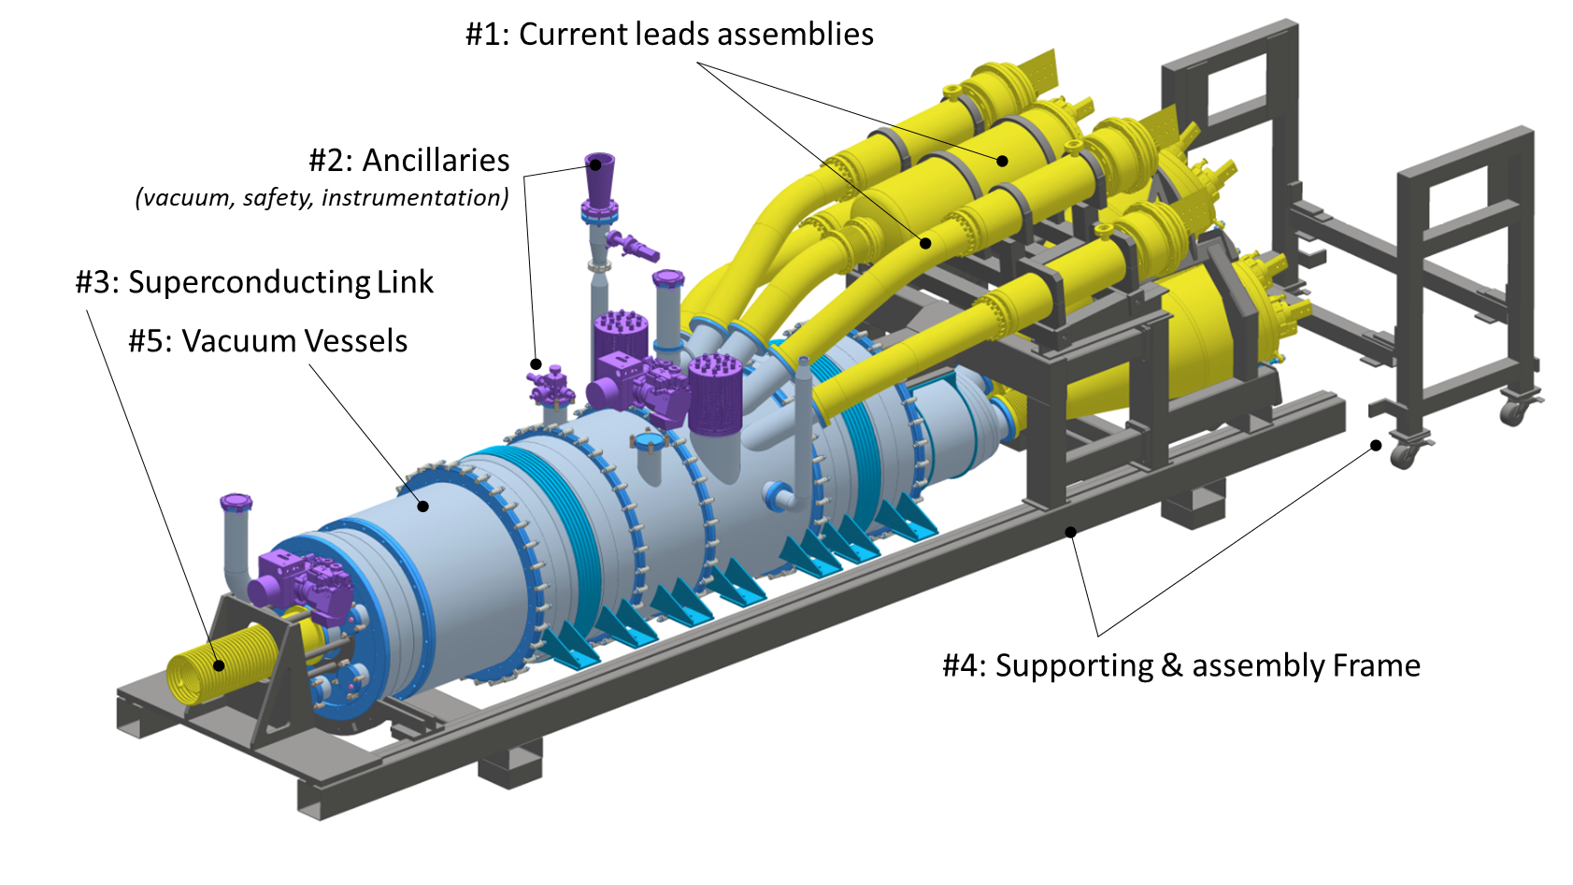

**Figure 1**: DFHX definition of main sets: external components

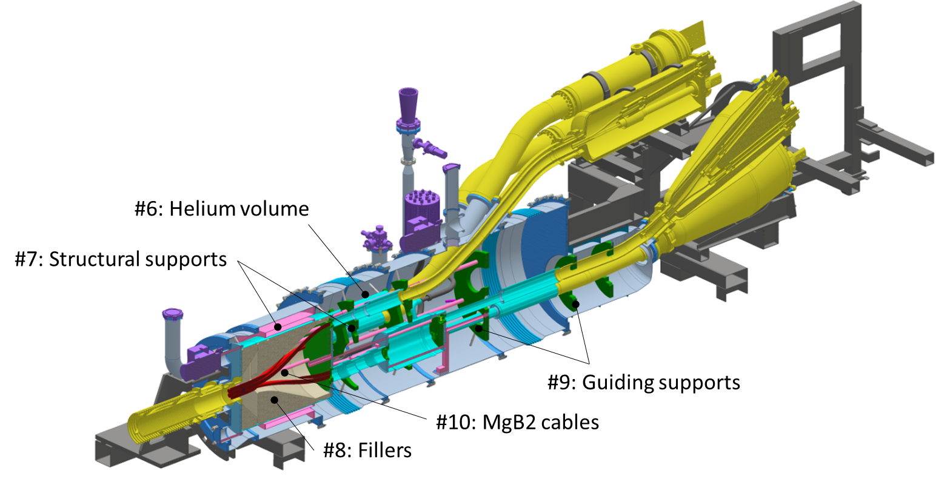

**Figure 2**: DFHX definition of main sets: internal components

**Table 1:** DFHX main sets responsible

|  |  |  |  |
| --- | --- | --- | --- |
| Set | Ref: | Contains: | Supplier |
| #1 | Current leads assemblies | * Electrical copper current lead * Helium reservoir * Vacuum vessel * Concentric flexibles * HTS cable | CERN  magnet group |
| #2 | Ancillaries | * Safety relief pressure devices * Instrumentation feedthroughs, sensors and cabling * Vacuum gauges * Vacuum pumps | CERN  Various groups |
| #3 | Superconducting link | * Concentric stainless steel flexibles * MgB2 cable bundle | CERN  Magnet group |
| #4 | **Supporting Frame** | * Structural beams * Guiding rails * Simple screwed adjustment systems * Assembly trolley | **Upsala University** |
| #5 | **Vacuum vessels** | * Tubes (304L, 316L) * Flanges (316L) ? * ISO-K flanges and O-rings assembly * Vacuum vessel bellows | **Upsala University** |
| #6 | **Helium volume** | * Tubes (304L, 316L) * Machined interface weldable flanges (forged rings/blanks) * Braided flexibles (316L) * Pressurised bellows | **Upsala University** |
| #7 | **Structural supports** | * Vacuum barrier (304L, 316L) * Adjusting rods (304L, 316L) * Supports (304L, 316L) | **Upsala University** |
| #8 | Fillers | * ROHACEL | CERN |
| #9 | **Guiding supports** | * Various design/ sizes (G10) | **Upsala university** |
| #10 | MgB2 cables | * 19 conductors * Electrical connections | CERN |

# Delivery configuration

Figure 3 illustrates the components supplied by the Upsala University in the DFHX assembly configuration. The assembly sequence of the DFHX includes inserting and processing the cables and therefore cannot be performed without cables. Consequently, the components supply covers sub-assemblies which will be welded after cable assembly. A preliminary list of sub-assemblies as delivered is illustrated Table 2.

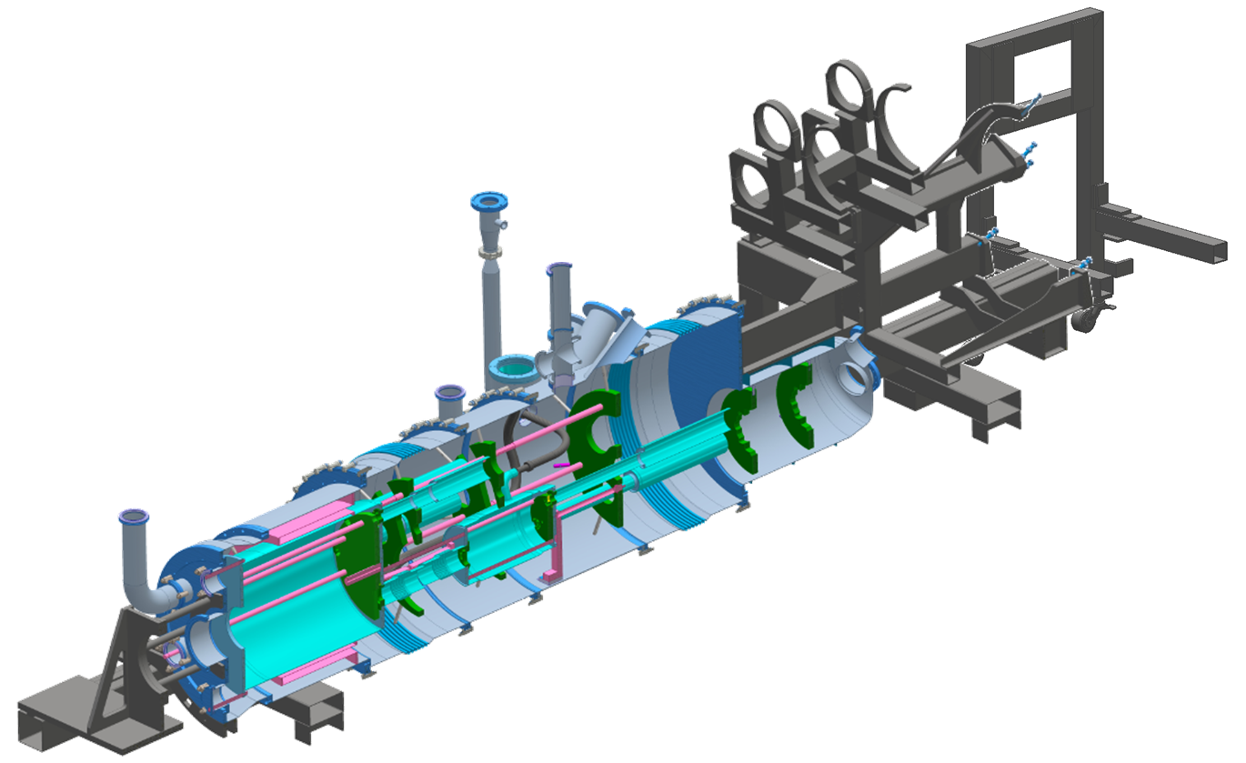

**Figure 3**: DFHX components delivered by Upsala University in the final assembled configuration

The following files presenting a preliminary design of the DFHX are attached to this document:

* DFHX_Feb2020_Full_configuration / Head of assembly : CAD1461631, see Figure1.
* DFHX_Feb2020_Components_delivered_by_Upsala / Head of assembly : CAD1461631, see figure 3.

**Table 2:** Sub-assemblies as delivered for cable integration at CERN.

|  |  |  |  |
| --- | --- | --- | --- |
| **Sub-assemblies of frame parts and assembly trolley** | | | |
|  | |  | |
|  | |  | |
| **Sub-assemblies of vacuum vessel associated parts** | | | |
|  | | | |
|  |  | |  |
| 1 | 2 | | 3 |
|  |  | |  |
| 4 | 5 | | 6 |
|  |  | |  |
| 7 | 8 | |  |
| **Structural, tooling & guiding parts** | | | |
|  | | | |
| **Individual sub-assemblies for helium volume** | | | |
|  | | | |
|  |  | |  |
| 1 | 2 | | 3 |
|  |  | |  |
| 4 | 5 | |  |

# references